Structure From Motion From Two Views

[Open Script](matlab:edit%20StructureFromMotionExample)

Structure from motion (SfM) is the process of estimating the 3-D structure of a scene from a set of 2-D images. This example shows you how to estimate the poses of a calibrated camera from two images, reconstruct the 3-D structure of the scene up to an unknown scale factor, and then recover the actual scale factor by detecting an object of a known size.

**Overview**

This example shows how to reconstruct a 3-D scene from a pair of 2-D images taken with a camera calibrated using the [Camera Calibrator app](matlab:helpview(fullfile(docroot,'toolbox','vision','vision.map'),'visionCameraCalibrator');). The algorithm consists of the following steps:

1. Match a sparse set of points between the two images. There are multiple ways of finding point correspondences between two images. This example detects corners in the first image using the detectMinEigenFeatures function, and tracks them into the second image using vision.PointTracker. Alternatively you can use extractFeatures followed by matchFeatures.
2. Estimate the fundamental matrix using estimateFundamentalMatrix.
3. Compute the motion of the camera using the relativeCameraPose function.
4. Match a dense set of points between the two images. Re-detect the point using detectMinEigenFeatures with a reduced 'MinQuality' to get more points. Then track the dense points into the second image using vision.PointTracker.
5. Determine the 3-D locations of the matched points using triangulate.
6. Detect an object of a known size. In this scene there is a globe, whose radius is known to be 10cm. Use pcfitsphere to find the globe in the point cloud.
7. Recover the actual scale, resulting in a metric reconstruction.

**Read a Pair of Images**

Load a pair of images into the workspace.

imageDir = fullfile(toolboxdir('vision'), 'visiondata','upToScaleReconstructionImages');

% 'C:\Program Files\MATLAB\R2017a\toolbox\vision\visiondata\upToScaleReconstructionImages'

images = imageDatastore(imageDir);

% 读取上面目录下的多个图片文件

I1 = readimage(images, 1);

I2 = readimage(images, 2);

figure

imshowpair(I1, I2, 'montage');

title('Original Images');

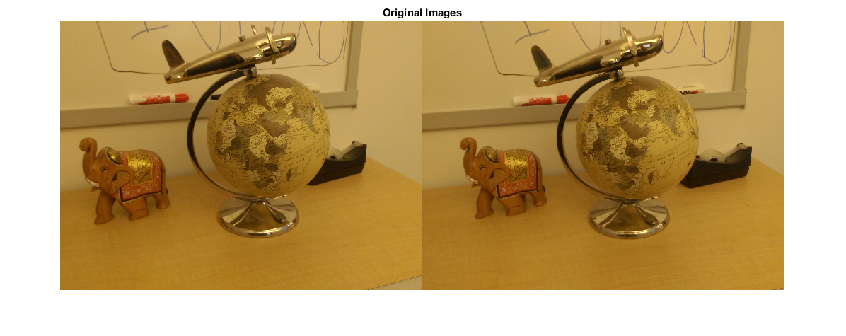

**Load Camera Parameters**

This example uses the camera parameters calculated by the [cameraCalibrator](matlab:helpview(fullfile(docroot,'toolbox','vision','vision.map'),'visionCameraCalibrator');" \t "_top) app. The parameters are stored in the cameraParams object, and include the camera intrinsics and lens distortion coefficients.

% Load precomputed camera parameters

load upToScaleReconstructionCameraParameters.mat

**Remove Lens Distortion**

Lens distortion can affect the accuracy of the final reconstruction. You can remove the distortion from each of the images using the undistortImage function. This process straightens the lines that are bent by the radial distortion of the lens.

I1 = undistortImage(I1, cameraParams);

I2 = undistortImage(I2, cameraParams);

figure

imshowpair(I1, I2, 'montage');

title('Undistorted Images');

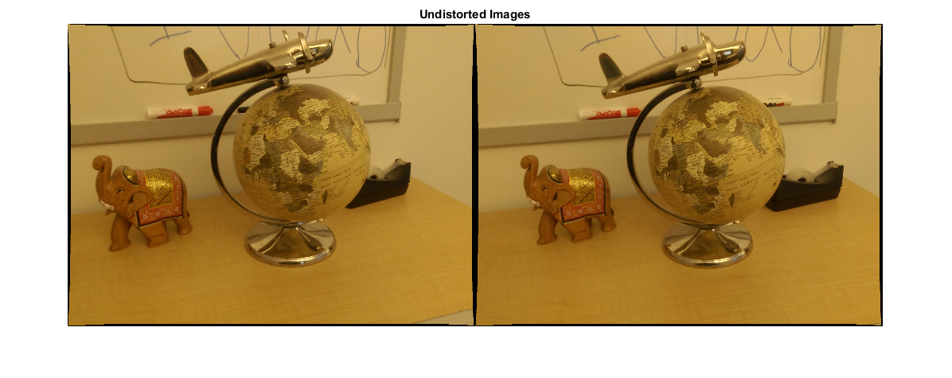

**Find Point Correspondences Between The Images**

Detect good features to track. Reduce 'MinQuality' to detect fewer points, which would be more uniformly distributed throughout the image. If the motion of the camera is not very large, then tracking using the KLT algorithm is a good way to establish point correspondences.

% Detect feature points

imagePoints1 = detectMinEigenFeatures(rgb2gray(I1), 'MinQuality', 0.1);

% Visualize detected points

figure

imshow(I1, 'InitialMagnification', 50);

title('150 Strongest Corners from the First Image');

hold on

plot(selectStrongest(imagePoints1, 150));

% Create the point tracker

tracker = vision.PointTracker('MaxBidirectionalError', 1, 'NumPyramidLevels', 5);

% Initialize the point tracker

imagePoints1 = imagePoints1.Location;

initialize(tracker, imagePoints1, I1);

% Track the points

[imagePoints2, validIdx] = step(tracker, I2);

matchedPoints1 = imagePoints1(validIdx, :);

matchedPoints2 = imagePoints2(validIdx, :);

% Visualize correspondences

figure

showMatchedFeatures(I1, I2, matchedPoints1, matchedPoints2);

title('Tracked Features');

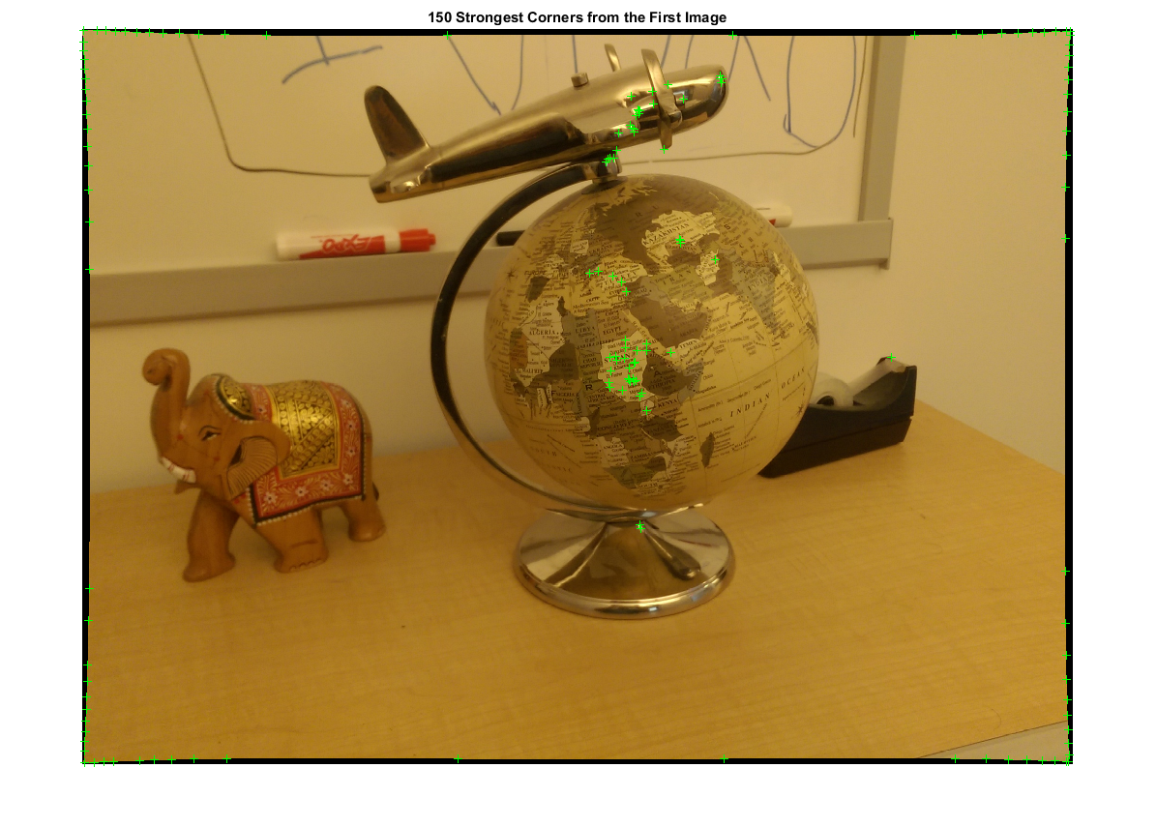

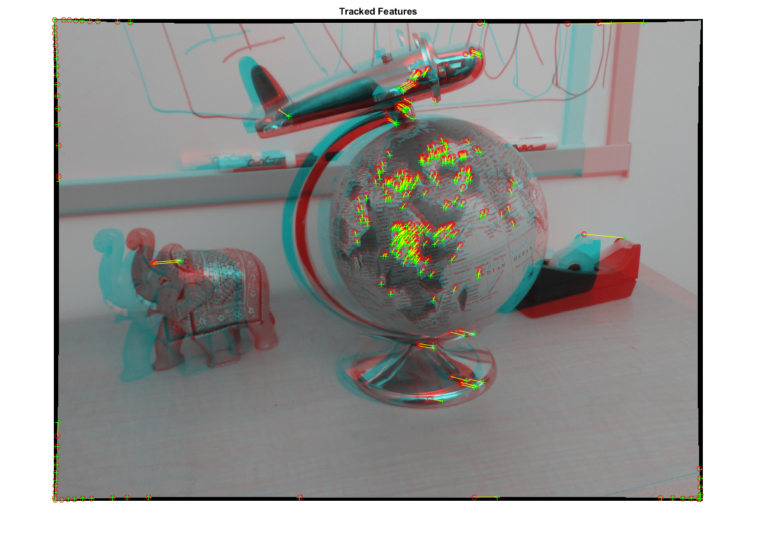

**Estimate the Essential Matrix**

Use the estimateEssentialMatrix function to compute the essential matrix and find the inlier points that meet the epipolar constraint.

% Estimate the fundamental matrix

[E, epipolarInliers] = estimateEssentialMatrix(...

matchedPoints1, matchedPoints2, cameraParams, 'Confidence', 99.99);

% Find epipolar inliers

inlierPoints1 = matchedPoints1(epipolarInliers, :);

inlierPoints2 = matchedPoints2(epipolarInliers, :);

% Display inlier matches

figure

showMatchedFeatures(I1, I2, inlierPoints1, inlierPoints2);

title('Epipolar Inliers');

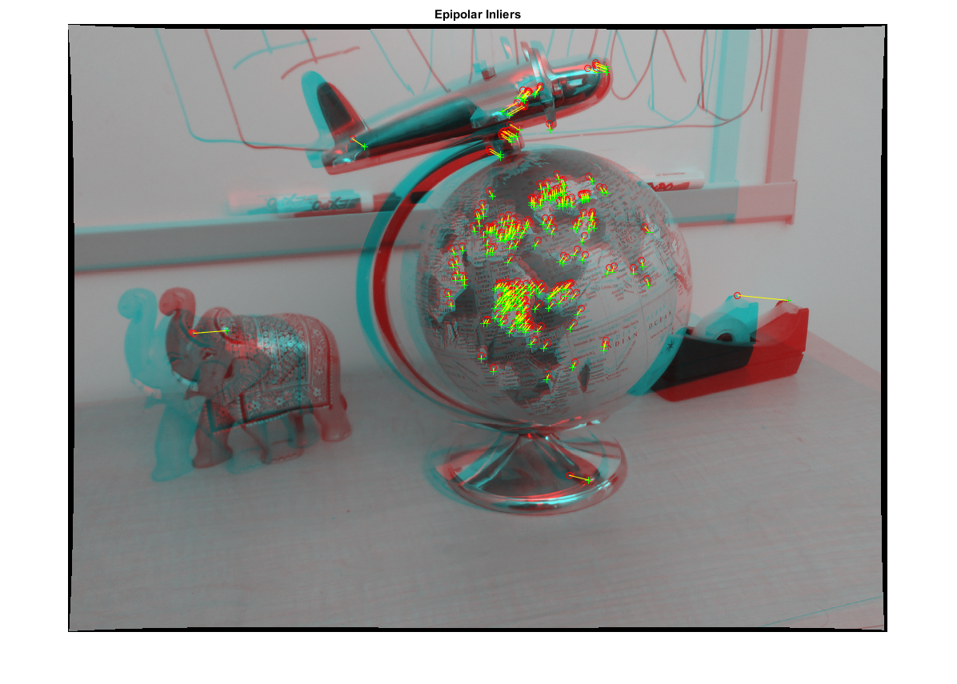

**Compute the Camera Pose**

Compute the location and orientation of the second camera relative to the first one. Note that t is a unit vector, because translation can only be computed up to scale.

[orient, loc] = relativeCameraPose(E, cameraParams, inlierPoints1, inlierPoints2);

**Reconstruct the 3-D Locations of Matched Points**

Re-detect points in the first image using lower 'MinQuality' to get more points. Track the new points into the second image. Estimate the 3-D locations corresponding to the matched points using the triangulate function, which implements the Direct Linear Transformation (DLT) algorithm [1]. Place the origin at the optical center of the camera corresponding to the first image.

% Detect dense feature points. Use an ROI to exclude points close to the

% image edges.

roi = [30, 30, size(I1, 2) - 30, size(I1, 1) - 30];

imagePoints1 = detectMinEigenFeatures(rgb2gray(I1), 'ROI', roi, ...

'MinQuality', 0.001);

% Create the point tracker

tracker = vision.PointTracker('MaxBidirectionalError', 1, 'NumPyramidLevels', 5);

% Initialize the point tracker

imagePoints1 = imagePoints1.Location;

initialize(tracker, imagePoints1, I1);

% Track the points

[imagePoints2, validIdx] = step(tracker, I2);

matchedPoints1 = imagePoints1(validIdx, :);

matchedPoints2 = imagePoints2(validIdx, :);

% Compute the camera matrices for each position of the camera

% The first camera is at the origin looking along the Z-axis. Thus, its

% rotation matrix is identity, and its translation vector is 0.

camMatrix1 = cameraMatrix(cameraParams, eye(3), [0 0 0]);

% Compute extrinsics of the second camera

[R, t] = cameraPoseToExtrinsics(orient, loc);

camMatrix2 = cameraMatrix(cameraParams, R, t);

% Compute the 3-D points

points3D = triangulate(matchedPoints1, matchedPoints2, camMatrix1, camMatrix2);

% Get the color of each reconstructed point

numPixels = size(I1, 1) \* size(I1, 2);

allColors = reshape(I1, [numPixels, 3]);

colorIdx = sub2ind([size(I1, 1), size(I1, 2)], round(matchedPoints1(:,2)), ...

round(matchedPoints1(:, 1)));

color = allColors(colorIdx, :);

% Create the point cloud

ptCloud = pointCloud(points3D, 'Color', color);

**Display the 3-D Point Cloud**

Use the plotCamera function to visualize the locations and orientations of the camera, and the pcshow function to visualize the point cloud.

% Visualize the camera locations and orientations

cameraSize = 0.3;

figure

plotCamera('Size', cameraSize, 'Color', 'r', 'Label', '1', 'Opacity', 0);

hold on

grid on

plotCamera('Location', loc, 'Orientation', orient, 'Size', cameraSize, ...

'Color', 'b', 'Label', '2', 'Opacity', 0);

% Visualize the point cloud

pcshow(ptCloud, 'VerticalAxis', 'y', 'VerticalAxisDir', 'down', ...

'MarkerSize', 45);

% Rotate and zoom the plot

camorbit(0, -30);

camzoom(1.5);

% Label the axes

xlabel('x-axis');

ylabel('y-axis');

zlabel('z-axis')

title('Up to Scale Reconstruction of the Scene');

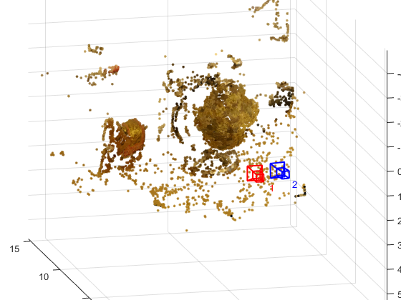

**Fit a Sphere to the Point Cloud to Find the Globe**

Find the globe in the point cloud by fitting a sphere to the 3-D points using the pcfitsphere function.

% Detect the globe

globe = pcfitsphere(ptCloud, 0.1);

% Display the surface of the globe

plot(globe);

title('Estimated Location and Size of the Globe');

hold off

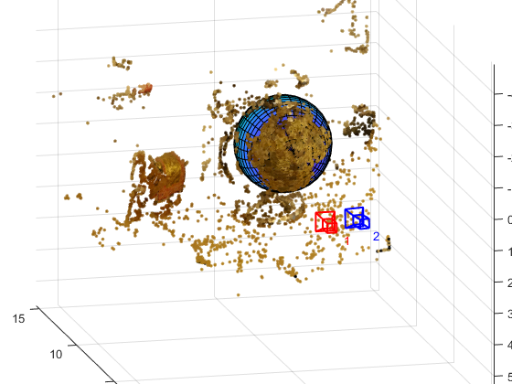

**Metric Reconstruction of the Scene**

The actual radius of the globe is 10cm. You can now determine the coordinates of the 3-D points in centimeters.

% Determine the scale factor

scaleFactor = 10 / globe.Radius;

% Scale the point cloud

ptCloud = pointCloud(points3D \* scaleFactor, 'Color', color);

loc = loc \* scaleFactor;

% Visualize the point cloud in centimeters

cameraSize = 2;

figure

plotCamera('Size', cameraSize, 'Color', 'r', 'Label', '1', 'Opacity', 0);

hold on

grid on

plotCamera('Location', loc, 'Orientation', orient, 'Size', cameraSize, ...

'Color', 'b', 'Label', '2', 'Opacity', 0);

% Visualize the point cloud

pcshow(ptCloud, 'VerticalAxis', 'y', 'VerticalAxisDir', 'down', ...

'MarkerSize', 45);

camorbit(0, -30);

camzoom(1.5);

% Label the axes

xlabel('x-axis (cm)');

ylabel('y-axis (cm)');

zlabel('z-axis (cm)')

title('Metric Reconstruction of the Scene');

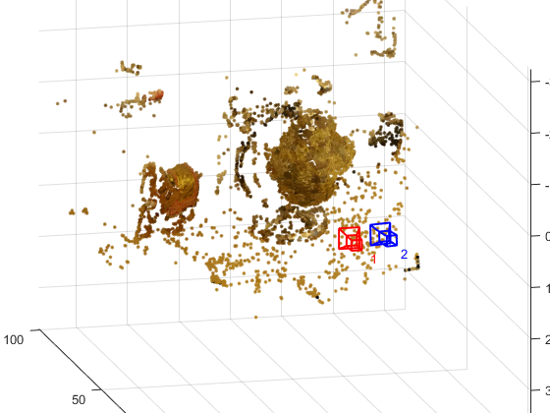

**Summary**

This example showed how to recover camera motion and reconstruct the 3-D structure of a scene from two images taken with a calibrated camera.

**References**

[1] Hartley, Richard, and Andrew Zisserman. Multiple View Geometry in Computer Vision. Second Edition. Cambridge, 2000.